Conduct the following experiments on an ARM CORTEX M3 evaluation board using evaluation version of Embedded 'C' & Keil Uvision-4 tool/compiler.

**1. Blink an LED with software delay**

#include <lpc17xx.h>

void delay_ms(unsigned int ms)

{

unsigned int i,j;

for(i=0;i<ms;i++)

for(j=0;j<20000;j++);

}

/* start the main program */

int main(void)

{

SystemInit(); /*Clock and PLL configuration*/

LPC_PINCON->PINSEL4 = 0xffffffff; /*Configure the PORT2 Pins as GPIO;*/

LPC_GPIO2->FIODIR = 0xffffffff; /*Configure the PORT2 pins as OUTPUT;*/

while(1)

{

LPC_GPIO2->FIOSET = 0xffffffff; /* Make all the Port pins as high */

delay_ms(10);

LPC_GPIO2->FIOCLR = 0xffffffff; /* Make all the Port pins as low */

delay_ms(10);

}

}

Output:

In Peripherals 🡺 GPIO pins 🡺 check pin 2 to see the pins.

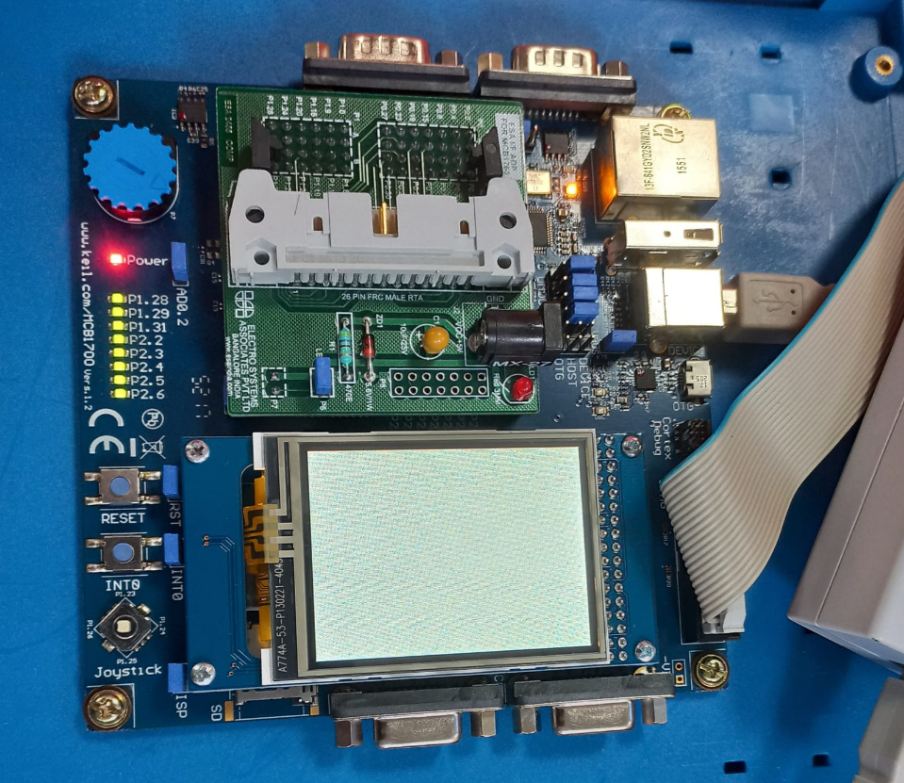 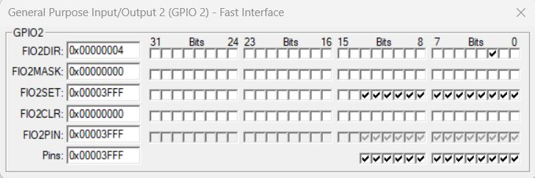

**2. Blink an LED with delay generated using the SysTick timer.**

#include <LPC17xx.h>

/* Systick Register address, refer datasheet for more info */

#define STCTRL (*( ( volatile unsigned long *) 0xE000E010 ))

#define STRELOAD (*( ( volatile unsigned long *) 0xE000E014 ))

#define STCURR (*( ( volatile unsigned long *) 0xE000E018 ))

/*******STCTRL bits*******/

#define SBIT_ENABLE 0

#define SBIT_TICKINT 1

#define SBIT_CLKSOURCE 2 /* 100000000Mhz * 1ms = 1000000 - 1 */

#define RELOAD_VALUE 99999999

#define LED 2 //P2_2

int main (void)

{

SystemInit();

STRELOAD = RELOAD_VALUE; // Reload value for 100ms tick

/* Enable the Systick, Systick Interrup and select CPU Clock Source */

STCTRL = (1<<SBIT_ENABLE) | (1<<SBIT_TICKINT) | (1<<SBIT_CLKSOURCE);

LPC_GPIO2->FIODIR = (1<<LED); /* Configure the Led Pin as Output */

while(1)

{

//do nothing

}

}

void SysTick_Handler(void)

{

LPC_GPIO2->FIOPIN ^= (1<<LED); /* Toggle the LED1 (P2_0) */

}

Output:





**3. System clock real time alteration using the PLL modules.**

#include <LPC17xx.h>

#define CCLKCFG (*(volatile unsigned long *)(0x400FC104))

#define PLL0CON (*(volatile unsigned long *)(0x400FC080))

#define PLL0FEED (*(volatile unsigned long *)(0x400FC08C))

#define PLL0STAT (*(volatile unsigned long *)(0x400FC088))

#define PLL0CFG (*(volatile unsigned long *)(0x400FC084))

// function prototypes

void delay(void);

int main() {

LPC_GPIO2->FIODIR |= 0x0000007C;

//CCLKCFG=0x000000EE; // divider divides by this number plus 1

// Set PLL0 multiplier

PLL0CFG = 0x0015013A; //arbitrary multiply value, divide value left at 1

PLL0FEED = 0x000000AA; // Feed the PLL

PLL0FEED = 0x00000055;

// Turn on PLL0

PLL0CON |= 1<<0;

PLL0FEED = 0x000000AA; // Feed the PLL

PLL0FEED = 0x00000055;

// Wait for main PLL (PLL0) to come up

while ((PLL0STAT & (1<<24)) == 0x00);

// Wait for PLOCK0 to become 1

while ((PLL0STAT & (1<<26)) == 0x00);

// Connect to the PLL0

PLL0CON |= 1<<1;

PLL0FEED = 0x000000AA; // Feed the PLL

PLL0FEED = 0x00000055;

while ((PLL0STAT & (1<<25)) == 0x00); //Wait for PLL0 to connect

while(1) {

LPC_GPIO2->FIOPIN ^= (0x0000007C);

delay();

}

}

void delay(void)

{ //delay function.

int j; //loop variable j

for (j=0;j<50000;j++)

{

j++;

j--; //waste time

}

}

Output:

In options panel go to debug panel, select option ‘use JLINK’ and change text to DARMP1.sll and on right side TARMP1.sll

Go to peripherals 🡺 System clock 🡺 PLL 0

When PLL is On , the SYSCLK and PLLCLK are different and PLLCLK>SYSCLK.

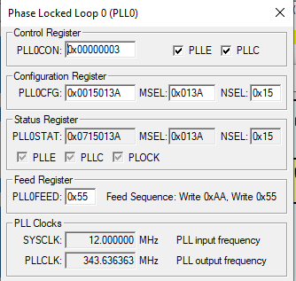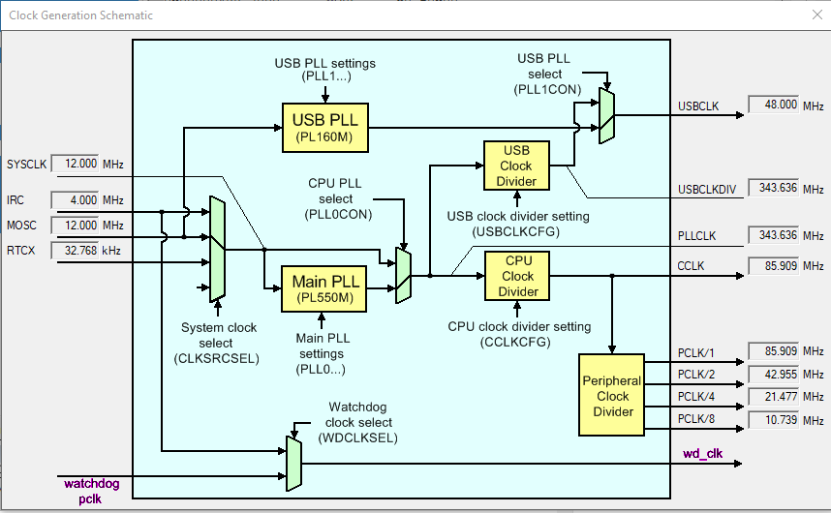

**PLL Off**

#include <LPC17xx.h>

#define CCLKCFG (*(volatile unsigned char *)(0x400FC104))

#define PLL0CON (*(volatile unsigned char *)(0x400FC080))

#define PLL0FEED (*(volatile unsigned char *)(0x400FC08C))

#define PLL0STAT (*(volatile unsigned char *)(0x400FC088))

// function prototypes

void delay(void);

int main() {

LPC_GPIO2->FIODIR |= 0x0000007C;

CCLKCFG = 0x000000FF;

// Disconnect PLL0

PLL0CON &= !(1<<1); // Clears bit 1 of PLL0CON, the Connect bit

PLL0FEED = 0xAA; // Feed the PLL. Enables action of above line

PLL0FEED = 0x55; //

// Wait for PLL0 to disconnect. Wait for bit 25 to become 0.

while ((PLL0STAT & (1<<25)) != 0x00);//Bit 25 shows connection status

// Turn off PLL0; on completion, PLL0 is bypassed.

PLL0CON &= !(1<<0); //Bit 0 of PLL0CON disables PLL

PLL0FEED = 0xAA; // Feed the PLL. Enables action of above line

PLL0FEED = 0x55;

// Wait for PLL0 to shut down

while ((PLL0STAT & (1<<24)) != 0x00);//Bit 24 shows enable status

/****Insert Optional Extra Code Here****

to change PLL0 settings or clock source.

**OR** just continue with PLL0 disabled and bypassed*/

//blink at the new clock frequency

while(1) {

LPC_GPIO2->FIOPIN ^= (0x0000007C);

delay();

}

}

void delay(void)

{ //delay function.

int j; //loop variable j

for (j=0;j<5000000;j++)

{

j++;

j--; //waste time

}

}

Output:

In options panel go to debug panel, select option ‘use JLINK’ and change text to DARMP1.sll and on right side TARMP1.sll

Go to peripherals 🡺 System clock 🡺 PLL 0

When PLL is Off , the SYSCLK and PLLCLK are same and PLLCLK=SYSCLK.

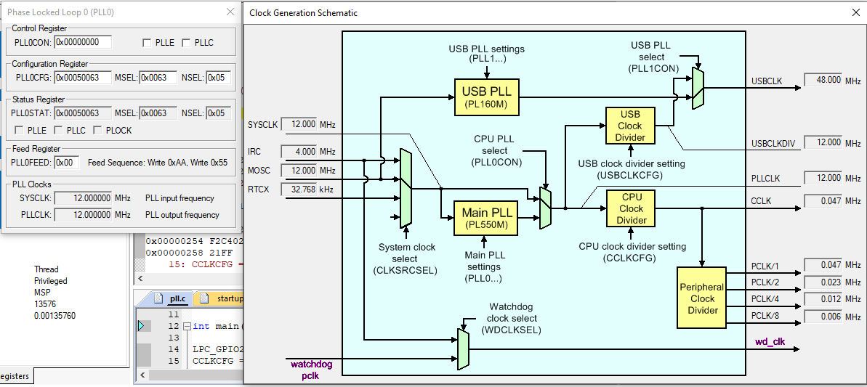

**4. Using the Internal PWM module of ARM controller generate PWM and vary its duty cycle.**

#include <lpc17xx.h>

void delay_ms(unsigned int ms)

{

unsigned int i,j;

for(i=0;i<ms;i++)

for(j=0;j<50000;j++);

}

#define SBIT_CNTEN 0

#define SBIT_PWMEN 2

#define SBIT_PWMMR0R 1

#define SBIT_LEN0 0

#define SBIT_LEN1 1

#define SBIT_LEN2 2

#define SBIT_LEN3 3

#define SBIT_LEN4 4

#define SBIT_PWMENA1 9

#define SBIT_PWMENA2 10

#define SBIT_PWMENA3 11

#define SBIT_PWMENA4 12

#define PWM_1 0 //P2_0 (0-1 Bits of PINSEL4)

#define PWM_2 2 //P2_1 (2-3 Bits of PINSEL4)

#define PWM_3 4 //P2_2 (4-5 Bits of PINSEL4)

#define PWM_4 6 //P2_3 (6-7 Bits of PINSEL4)

int main(void)

{

int dutyCycle;

SystemInit();

/* Cofigure pins(P2_0 - P2_3) for PWM mode. */

LPC_PINCON->PINSEL4 = (1<<PWM_1) | (1<<PWM_2) | (1<<PWM_3) | (1<<PWM_4);

/* Enable Counters,PWM module */

LPC_PWM1->TCR = (1<<SBIT_CNTEN) | (1<<SBIT_PWMEN);

LPC_PWM1->PR = 0x0; /* No Prescalar */

LPC_PWM1->MCR = (1<<SBIT_PWMMR0R); /*Reset on PWMMR0, reset TC if it matches MR0 */

LPC_PWM1->MR0 = 100; /* set PWM cycle(Ton+Toff)=100) */

LPC_PWM1->MR1 = 50; /* Set 50% Duty Cycle for all four channels */

LPC_PWM1->MR2 = 50;

LPC_PWM1->MR3 = 50;

LPC_PWM1->MR4 = 50;

/* Trigger the latch Enable Bits to load the new Match Values */

LPC_PWM1->LER = (1<<SBIT_LEN0) | (1<<SBIT_LEN1) | (1<<SBIT_LEN2) | (1<<SBIT_LEN3) | (1<<SBIT_LEN4);

/* Enable the PWM output pins for PWM_1-PWM_4(P2_0 - P2_3) */

LPC_PWM1->PCR = (1<<SBIT_PWMENA1) | (1<<SBIT_PWMENA2) | (1<<SBIT_PWMENA3) | (1<<SBIT_PWMENA4);

while(1)

{

for(dutyCycle=0; dutyCycle<100; dutyCycle++)

{

LPC_PWM1->MR1 = dutyCycle; /* Increase the dutyCycle from 0-100 */

LPC_PWM1->MR2 = dutyCycle;

LPC_PWM1->MR3 = dutyCycle;

LPC_PWM1->MR4 = dutyCycle;

/* Trigger the latch Enable Bits to load the new Match Values */

LPC_PWM1->LER = (1<<SBIT_LEN0) | (1<<SBIT_LEN1) | (1<<SBIT_LEN2) | (1<<SBIT_LEN3) | (1<<SBIT_LEN4);

delay_ms(5);

}

for(dutyCycle=100; dutyCycle>0; dutyCycle--)

{

LPC_PWM1->MR1 = dutyCycle; /* Decrease the dutyCycle from 100-0 */

LPC_PWM1->MR2 = dutyCycle;

LPC_PWM1->MR3 = dutyCycle;

LPC_PWM1->MR4 = dutyCycle;

/* Trigger the latch Enable Bits to load the new Match Values */

LPC_PWM1->LER = (1<<SBIT_LEN0) | (1<<SBIT_LEN1) | (1<<SBIT_LEN2) | (1<<SBIT_LEN3) | (1<<SBIT_LEN4);

delay_ms(5);

}

}

}

Output:

Go to logic Analyzer (in View Panel) 🡺 setup🡺add pins by select add pin icon🡺 ‘port 2.1,2.2,2.3…’ and start analyser to see the below output. And disable and enable pin 11 to blink the LED. Change the display type to ‘bit’ in dropdown.

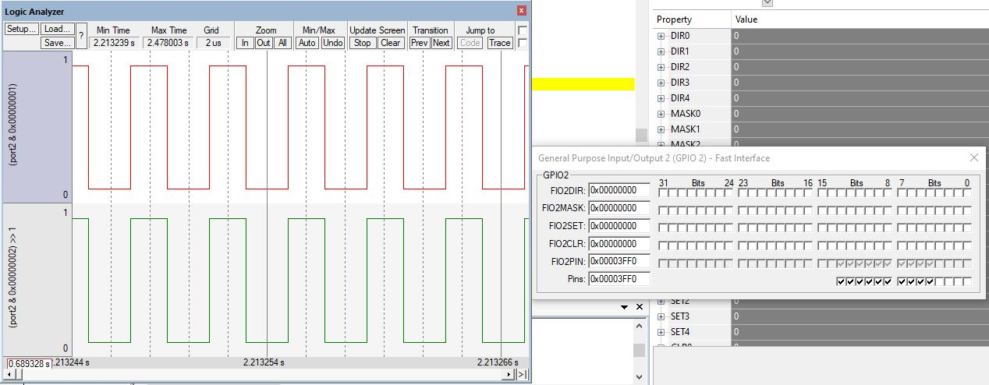

**5. Control an LED using switch by polling method**

#include <lpc17xx.h>

#define SwitchPinNumber 11

#define LedPinNumber 2

/* start the main program */

int main()

{

uint32_t switchStatus;

SystemInit(); /* Clock and PLL configuration */

LPC_PINCON->PINSEL4 = 0x000000; /* Configure the Pins for GPIO */

/* Configure the LED pin as output and SwitchPin as input */

LPC_GPIO2->FIODIR = ((1<<LedPinNumber) | (0<<SwitchPinNumber));

while(1)

{

/* Turn On all the leds and wait for one second */

switchStatus = (LPC_GPIO2->FIOPIN>>SwitchPinNumber) & 0x01 ; /* Read the switch status */

if(switchStatus == 1) /* Turn ON/OFF LEDs depending on switch status */

{

LPC_GPIO2->FIOPIN = (1<<LedPinNumber);

}

else

{

LPC_GPIO2->FIOPIN = (0<<LedPinNumber);

}

}

}

Output:

Mask pin 11(tick in FIO2MASK Column) to switch on/off the LED . Go to peripherals🡺GPIO Pins🡺Pin2

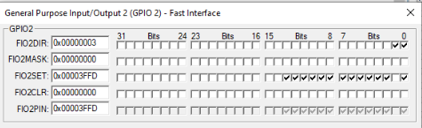

**6. Control an LED using switch by interrupt method**

#include <lpc17xx.h>

#define PINSEL_EINT0 20

#define PINSEL_EINT1 22

#define LED1 0

#define LED2 1

#define SBIT_EINT0 0

#define SBIT_EINT1 1

#define SBIT_EXTMODE0 0

#define SBIT_EXTMODE1 1

#define SBIT_EXTPOLAR0 0

#define SBIT_EXTPOLAR1 1

void EINT0_IRQHandler(void)

{

LPC_SC->EXTINT = (1<<SBIT_EINT0); /* Clear Interrupt Flag */

LPC_GPIO2->FIOPIN ^= (1<< LED1); /* Toggle the LED1 everytime INTR0 is generated */

}

void EINT1_IRQHandler(void)

{

LPC_SC->EXTINT = (1<<SBIT_EINT1); /* Clear Interrupt Flag */

LPC_GPIO2->FIOPIN ^= (1<< LED2); /* Toggle the LED2 everytime INTR1 is generated */

}

int main()

{

SystemInit();

LPC_SC->EXTINT = (1<<SBIT_EINT0) | (1<<SBIT_EINT1); /* Clear Pending interrupts */

LPC_PINCON->PINSEL4 = (1<<PINSEL_EINT0) | (1<<PINSEL_EINT1); /* Configure P2_10,P2_11 as EINT0/1 */

LPC_SC->EXTMODE = (1<<SBIT_EXTMODE0) | (1<<SBIT_EXTMODE1); /* Configure EINTx as Edge Triggered*/

LPC_SC->EXTPOLAR = (1<<SBIT_EXTPOLAR0)| (1<<SBIT_EXTPOLAR0); /* Configure EINTx as Falling Edge */

LPC_GPIO2->FIODIR = (1<<LED1) | (1<<LED2); /* Configure LED pins as OUTPUT */

LPC_GPIO2->FIOPIN = 0x00;

NVIC_EnableIRQ(EINT0_IRQn); /* Enable the EINT0,EINT1 interrupts */

NVIC_EnableIRQ(EINT1_IRQn);

while(1)

{

// Do nothing

}

}

Output:

Go to peripherals🡺GPIO Pins🡺Pin2



**7. Display “Hello World” message using Internal UART**

#include<LPC17xx.h>

void delay(unsigned int r1);

void UART0_Init(void);

void UART0_IRQHandler(void);

unsigned long int r=0, i = 0;

unsigned char tx0_flag=0;

unsigned char *ptr, arr[] = "Hello world";

int main(void)

{

SystemInit();

SystemCoreClockUpdate();

UART0_Init();

while(1)

{

ptr = arr;

while ( *ptr != '\0'){

LPC_UART0->THR = *ptr++;

while(tx0_flag == 0x00);

tx0_flag = 0x00;

for (i=0; i<200; i++);

}

for (i=0; i<500; i++)

delay(625); //delay

}

}

void UART0_Init(void)

{

LPC_SC->PCONP |= 0x00000008; //UART0 peripheral enable

LPC_PINCON->PINSEL0 |= 0x00000050; //for selecting TX0[P0.2-->5:4] and RX0[P0.3-->7:6] of UART0

LPC_UART0->LCR = 0x00000083; //enable divisor latch, parity disable, 1 stop bit, 8bit word length line control register

LPC_UART0->DLM = 0X00;

LPC_UART0->DLL = 0x13; //select baud rate 9600 bps

LPC_UART0->LCR = 0X00000003;

LPC_UART0->FCR = 0x07;

LPC_UART0->IER = 0X03; //select Transmit and receive interrupt

NVIC_EnableIRQ(UART0_IRQn); //Assigning channel

}

void UART0_IRQHandler(void)

{

unsigned long Int_Stat;

Int_Stat = LPC_UART0->IIR; //reading the data from interrupt identification register

Int_Stat = Int_Stat & 0x06; //masking other than txmit int & rcve data indicator

if((Int_Stat & 0x02)== 0x02) //transmit interrupt

tx0_flag = 0xff;

}

void delay(unsigned int r1)

{

for(r=0;r<r1;r++);

}

Output:

Go to View 🡺 Serial Window 🡺UART #1

